August 2015 S.T.E.M. Newsletter
R. E. McNair Discovery Learning Academy
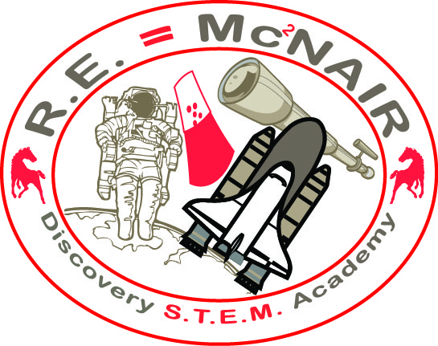

Upcoming Events

August 27
Open House
September 7
Labor Day Holiday
September 9 – 11, 16,18, & 21
ITBS Testing

September 16
Student of the Month Celebration
September 29
State S.T.E.M. walkthrough

Important Announcements
PTA Needs You! $10 pays for your membership for the entire school year!
Stay Connected:
Remind 101
Text @mcnairp to (703) 665-3093 to receive text messages directly to your cellphone regarding school announcements and information.

2162 Second Ave. Decatur GA 30032
http://www.mcnaires.dekalb.k12.ga.us/
http://www.classjump.com/R/REMcNairSTEMAcademy/
Telephone: 678-875-3402
Dear Parents,
I would like to inform you of all the Great things that have been happening here at Ronald E. McNair Discovery Learning Academy. We have had a state of the art Aquaponics system installed to increase the rigor land learning experiences of our students. Our staff will be receiving training in the upcoming months to provide the best educational experiences for your students. We have relocated the Research/Coding Lab to the Lab wing to provide our students with the connections needed between what they learn in the labs to their technology understanding. Along with these changes, we have acquired Makey Makeys to teach coding with the students and 3D printers for students to create 3D models. It is our goal to expand our program every year and to provide our students with competitive learning experiences. As we continue to expand the experience of our students we continue to need your support. We Thank you in advance and look forward to the great learning experiences of this year.
Sincerely,
Kaija Spencer, S.T.E.M. Coordinator

Why S.T.E.M.?
R.E. McNair Discovery S.T.E.M. Academy’s goal is to provide a rigorous Pre-K thru 5 integrated S.T.E.M. curriculum that will provide students with the needed academic and social skills to meet the challenges of the competitive global society.
What is R. E. McNair Discovery Learning Academy’s Mission?
R. E. McNair Discovery Learning Academy will be an internationally recognized school of the gifted in science, technology, engineering, and mathematics.

More STEM News

In the Community

Board of Education Citizen Input
August 3, 2015 at 5:45 to 6:45 at the Robert R. Freeman Administrative & Instructional complex (AIC) located at 1701 Mountain Industrial Blvd; Stone Mountain, GA 30083

Aquaponics
Our school is happy to announce that we have acquired a partnership with HATponics. This organization is a world-wide provider of Aquaponics systems to those in need. This organization will be assisting us in designing, developing, and maintaining a full aquaponics system. This system will provide learning opportunities for all students in grades K-5. This experience will be one of few in the district and the metro area.
We are excited to share this experience with our community and our students in the upcoming months.
Visit the HATponics website at http://www.hatponics.org/ to learn more..

